**Módulo 1, Sábado 1.**

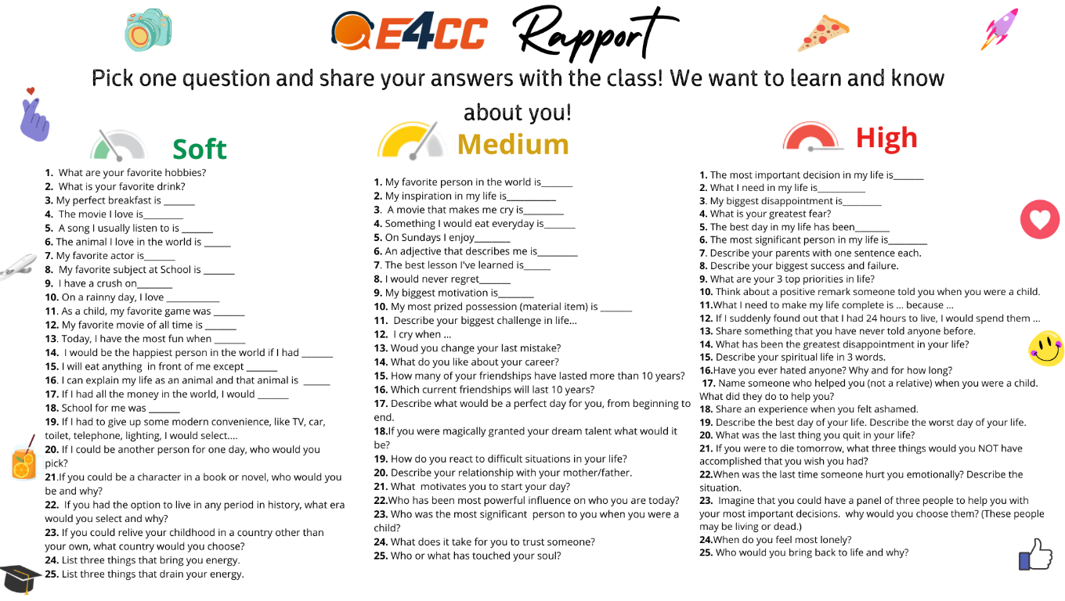

**Tell me about yourself?**

My name is Johny Driotis

I am from El Salvador

I live in San Salvador

I am 26 years old,

I am study at E4CC,

I am system engineer, nice to meet you.

**Greetings**

Good morning (Buenos días).

Good afternoon (Buenas tardes).

Good evening (Buenas noches).

Good night (Buenas noches ya para ir a dormir).

**Vowels**

A E I O U

**The alphabet**

A B C D E F G H I J K L M N O P Q R S T U V W X Y Z

**Deletreando palabras**

How do you spell Johny?

J O H N Y

How do you spell your name?

A L E X A N D E R

How do you spell your lastname?

D R I O T I S

**Verb to be**

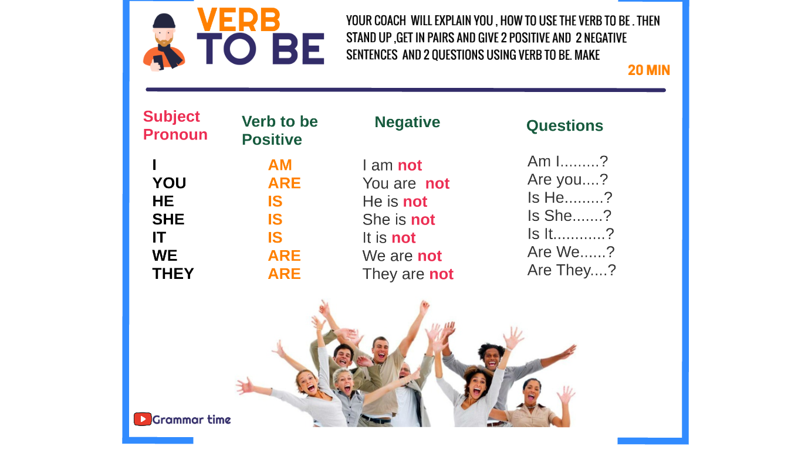

**Investigar sobre:**

Casual Greetings.

Formal Greetings